UA660
Stereo Amplifier

Product Description:  The UA Series 2U professional amplifiers have been engineered for reliability where full power is required for extended times in fixed installations or portable applications.. The UA Series delivers extraordinary performance at unmatched  value.  Key Features and Benefits:  - Housed in a rugged, all-steel 2U chassis  - Rear panel selection switch for Stereo, Parallel and Bridged modes, including Low-cut filter, Ground lift and Limiter switches  - Operates within 8Ω and 4Ω loads  - Innovative heatsink with front to back air flow for efficient cooling  - Variable fan speed is automatically adjusted by temperature  - Electronically balanced XLR inputs  - Touch proof binding post and Speakon outputs  - Precision indented level controls, power switch,  - Protect, Peak and Signal LEDs indicators for each channel  - Amplifier protection includes short circuit, excessive temperature, and DC on outputs  Front Panel:  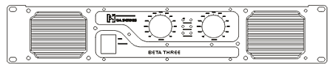  Rear Panel:  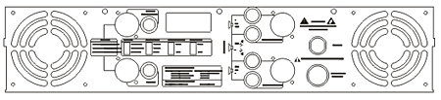
  Specifications
  Rated Power (Stereo 8 Ω) | 2 x 330W
  Rated Power (Stereo 4 Ω) | 2 x 500W
  Rated Power (Bridge 16 Ω) | 660W
  Rated Power (Bridge 8 Ω) | 1000W
  Rated Power (Parallel mono 8 Ω) | 350W
  Rated Power (Parallel mono 4 Ω) | 600W
  Input Sensitivity | 1V
  S/N Ratio (A Weight) | >108dB
  Frequency Response (+0/-0.25dB) | 20Hz-20kHz
  Damping Factor | >800 @ 8ohm/100Hz
  THD (10% Rated Power) | <0.05%
  Input Connector | 2 x XLR, 2 x 6.5mm TRS
  Input Impedance | 20kΩ Balanced, 10kΩ Unbalanced
  Output Connectors | 2 x NL4 + 4 x Binding post
  Cooling | 4 x fans, airflow from front to back
  Power Supply | 220V-230V 50/60Hz, 500VA
  Dimensions (W x D x H) | 483mm (19”) x 452mm (17.8”) x 88mm (3.5”)
  Packaging Dimensions (1 piece/pack) | 550mm (21.7”) x 540mm (21.3”) x 175mm (6.9”)
  Net Weight (1 piece/pack) | 15kg (33.1lb)
  Gross Weight (1 piece/pack) | 17kg (37.5lb)
  Mouseover image to zoom
  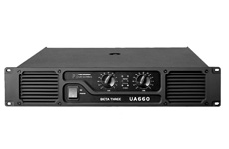
  Front View Back View Planform

